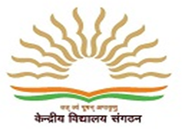
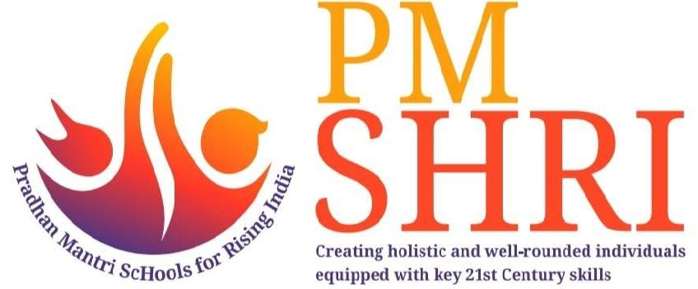
पीमश्रीकेन्द्रीयविद्यालय क्रमांक १, कुंजबन
PM SHRIKENDRIYA VIDYALAYA NO.1, KUNJABAN
राज्यसचिवालयकेसामने, न्यूकैपिटलकॉम्प्लेक्स
OppositeState Secretariat,New Capital Complex
(शिक्षा मंत्रालय, भारत सरकार)
(Ministry of Education, Govt. of India)
पिनकोड: 799010 दूरभाष:0381-2413873/2413363
Pin code: 799010Telephone: 0381-2413873/2413363
वेबसाइट:https://no1agartala.kvs.ac.in/ईमेल:kvkunjaban1@gmail.com
Website:https://no1agartala.kvs.ac.in/Email:kvkunjaban1@gmail.com

ESSENTIAL QUALIFICATIONS FOR POSTS OF PGT

- Two Year Integrated Post Graduate M.Sc.Course of Regional College of Education of NCERT in the subject concerned.
OR
Master’s Degree from a recognized university with at least 50% marks in aggregate in the following subject.

Sl.No | Post (Subject) | Subject(s) Post graduate level
1 | PGT- Chemistry | Chemistry/Bio Chemistry
2 | PGT-Pol.Science | Pol.Science

- B.Ed. or equivalent degree from a recognized University
- Proficiency in teaching in Hindi and English media.

Desirable Qualifications: knowledge of Computers.

ESSENTIAL QUALIFICATIONS FOR POSTS OF TGTs

- Four Years’ Integrated degree course of Regional College of Education of NCERT in the subject concerned subject with at least 50% marks in aggregate.
OR
Bachelor’s Degree with at least 50% marks in the concerned subject/combination of subjects and in aggregate. The electives subjects and Languages in the combination of subjects as under:
Sl.No | Post (Subject) | Subject(s) at Graduation level
1 | TGT- English | English as a subject in all the three years.
2 | TGT- Hindi | Hindi as a subject in all the three years.
3. | TGT- SOST | Any two of the following:  History, Geography, Economics and pol. Science of which one must be either History or Geography.
4. | TGT-Science | Botany, Zoology and Chemistry
5 | TGT-Sanskrit | Sanskrit as a subject in all the three years.
6 | TGT-Math | Bachelor Degree in Mathematics wit any two of the following subject:-  Physics, Chemistry, Electronics, Computer Science, statistics

- B.Ed or equivalent degree from a recognized University.
- Pass in the Central Teacher Eligibility Test (CTET) Paper-II,conducted by CBSE in accordance with the Guidelines framed by the NCET for the purpose.
- Proficiency in teaching in Hindi and English media.

Desirable Qualifications: knowledge of Computers.

ESSENTIAL QUALIFICATIONS FOR POSTS OF PRTs

Sl.No | Post (Subject) | Qualification(S)
1 | Primary Teacher | Essential:  1. Senior Secondary (or its equivalent) with at least 50% marks and 2-year Diploma in Elementary Education(by whatever name known)  OR  Senior Secondary(or its equivalent) with at least 50% marks and 4-year Bachelor of Elementary Education (B.El.Ed.)  OR  Senior Secondary(or its equivalent) with at least 50% marks and 2-year Diploma in Education(Special Education)  OR  Graduation with at least 50% marks and Bachelor of Education (B.Ed.)*  2. Qualified in the Central Teacher Eligibility Test (Paper-I) conducted by the Govt. of India.  3. Proficiency to teach through Hindi & English media.  Desirable:  Knowledge of working on Computer.  * Note: Preference will be given to D.El.Ed/B.El.Ed candidates

ESSENTIAL QUALIFICATIONS FOR POSTS OF miscellaneous post

Sl.No | Post (Subject) | Subject(s) at Graduation level
1 | Computer Instructor | B.E /B.Tech (IT/CS)/M.Sc(CS)/MCA OR B.E/B.Tech(any stream) with PGDCA
2 | Academic Counselor | Graduation/Masters in Psychology AND Diploma in Guidance & Counseling
3. | Special Educator | D.Ed/B.Ed in Special Education
4. | Nurse | ANM/GNM/B.Sc(Nursing) and should have valid Registration
5 | Games Expert/Coach | Bachelor Degree in Physical Education or Equivalent
6 | Yoga Coach | Graduation & One year/Certificate course in Yoga
7 | Dance Expert | Equivalent recognized Degree/Diploma
8 | Art Expert | Equivalent recognized Degree

